ap bio practice review exam ch.9

Multiple Choice
Identify the choice that best completes the statement or answers the question.

____ 1) Why does the oxidation of organic compounds by molecular oxygen to produce CO₂ and water release free energy?
A) | The covalent bonds in organic molecules and molecular oxygen have more kinetic energy than the covalent bonds in water and carbon dioxide.
B) | Electrons are being moved from atoms that have a lower affinity for electrons (such as C) to atoms with a higher affinity for electrons (such as O).
C) | The oxidation of organic compounds can be used to make ATP.
D) | The electrons have a higher potential energy when associated with water and CO₂ than they do in organic compounds.
E) | The covalent bond in O₂ is unstable and easily broken by electrons from organic molecules.

____ 2) When a molecule of NAD⁺ (nicotinamide adenine dinucleotide) gains a hydrogen atom (not a proton), the molecule becomes
A) | dehydrogenated.
B) | oxidized.
C) | reduced.
D) | redoxed.
E) | hydrolyzed.

____ 3) Where does glycolysis take place in eukaryotic cells?
A) | mitochondrial matrix
B) | mitochondrial outer membrane
C) | mitochondrial inner membrane
D) | mitochondrial intermembrane space
E) | cytosol

____ 4) The oxygen consumed during cellular respiration is involved directly in which process or event?
A) | glycolysis
B) | accepting electrons at the end of the electron transport chain
C) | the citric acid cycle
D) | the oxidation of pyruvate to acetyl CoA
E) | the phosphorylation of ADP to form ATP

____ 5) Which process in eukaryotic cells will proceed normally whether oxygen (O₂) is present or absent?
A) | electron transport
B) | glycolysis
C) | the citric acid cycle
D) | oxidative phosphorylation
E) | chemiosmosis

____ 6) During glycolysis, when each molecule of glucose is catabolized to two molecules of pyruvate, most of the potential energy contained in glucose is
A) | transferred to ADP, forming ATP.
B) | transferred directly to ATP.
C) | retained in the two pyruvates.
D) | stored in the NADH produced.
E) | used to phosphorylate fructose to form fructose 6–phosphate.

____ 7) The free energy for the oxidation of glucose to CO₂ and water is –686 kcal/mol and the free energy for the reduction of NAD⁺ to NADH is +53 kcal/mol. Why are only two molecules of NADH formed during glycolysis when it appears that as many as a dozen could be formed?
A) | Most of the free energy available from the oxidation of glucose is used in the production of ATP in glycolysis.
B) | Glycolysis is a very inefficient reaction, with much of the energy of glucose released as heat.
C) | Most of the free energy available from the oxidation of glucose remains in pyruvate, one of the products of glycolysis.
D) | There is no CO₂ or water produced as products of glycolysis.
E) | Glycolysis consists of many enzymatic reactions, each of which extracts some energy from the glucose molecule.

____ 8) Starting with one molecule of glucose, the energy–containing products of glycolysis are
A) | 2 NAD⁺, 2 pyruvate, and 2 ATP.
B) | 2 NADH, 2 pyruvate, and 2 ATP.
C) | FADH₂, 2 pyruvate, and 4 ATP.
D) | 6 CO₂, 2 ATP, and 2 pyruvate.
E) | 6 CO₂, 30 ATP, and 2 pyruvate.

____ 9) In glycolysis, for each molecule of glucose oxidized to pyruvate
A) | two molecules of ATP are used and two molecules of ATP are produced.
B) | two molecules of ATP are used and four molecules of ATP are produced.
C) | four molecules of ATP are used and two molecules of ATP are produced.
D) | two molecules of ATP are used and six molecules of ATP are produced.
E) | six molecules of ATP are used and six molecules of ATP are produced.

____ 10) Why is glycolysis described as having an investment phase and a payoff phase?
A) | It both splits molecules and assembles molecules.
B) | It attaches and detaches phosphate groups.
C) | It uses glucose and generates pyruvate.
D) | It shifts molecules from cytosol to mitochondrion.
E) | It uses stored ATP and then forms a net increase in ATP.

____ 11) The transport of pyruvate into mitochondria depends on the proton–motive force across the inner mitochondrial membrane. How does pyruvate enter the mitochondrion?
A) | active transport
B) | diffusion
C) | facilitated diffusion
D) | through a channel
E) | through a pore

____ 12) During cellular respiration, acetyl CoA accumulates in which location?
A) | cytosol
B) | mitochondrial outer membrane
C) | mitochondrial inner membrane
D) | mitochondrial intermembrane space
E) | mitochondrial matrix

____ 13) A young animal has never had much energy. He is brought to a veterinarian for help and is sent to the animal hospital for some tests. There they discover his mitochondria can use only fatty acids and amino acids for respiration, and his cells produce more lactate than normal. Of the following, which is the best explanation of his condition?
A) | His mitochondria lack the transport protein that moves pyruvate across the outer mitochondrial membrane.
B) | His cells cannot move NADH from glycolysis into the mitochondria.
C) | His cells contain something that inhibits oxygen use in his mitochondria.
D) | His cells lack the enzyme in glycolysis that forms pyruvate.
E) | His cells have a defective electron transport chain, so glucose goes to lactate instead of to acetyl CoA.

____ 14) Where are the proteins of the electron transport chain located?
A) | cytosol
B) | mitochondrial outer membrane
C) | mitochondrial inner membrane
D) | mitochondrial intermembrane space
E) | mitochondrial matrix

____ 15) Inside an active mitochondrion, most electrons follow which pathway?
A) | glycolysis → NADH → oxidative phosphorylation → ATP → oxygen
B) | citric acid cycle → FADH₂ → electron transport chain → ATP
C) | electron transport chain → citric acid cycle → ATP → oxygen
D) | pyruvate → citric acid cycle → ATP → NADH → oxygen
E) | citric acid cycle → NADH → electron transport chain → oxygen

____ 16) In chemiosmotic phosphorylation, what is the most direct source of energy that is used to convert ADP + i to ATP?
A) | energy released as electrons flow through the electron transport system
B) | energy released from substrate–level phosphorylation
C) | energy released from movement of protons through ATP synthase, against the electrochemical gradient
D) | energy released from movement of protons through ATP synthase, down the electrochemical gradient
E) | No external source of energy is required because the reaction is exergonic.

Figure 9.1 illustrates some of the steps (reactions) of glycolysis in their proper sequence. Each step is lettered. Use these letters to answer the questions.

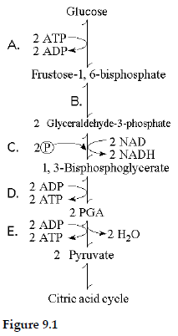

____ 17) Which step in Figure 9.1 is a redox reaction?
A) | A
B) | B
C) | C
D) | D
E) | E

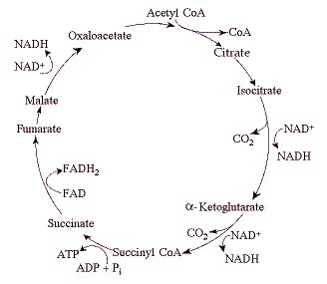
Figure 9.2 The citric acid cycle.

____ 18) If pyruvate oxidation is blocked, what will happen to the levels of oxaloacetate and citric acid in the citric acid cycle shown in Figure 9.2?
A) | There will be no change in the levels of oxaloacetate and citric acid.
B) | Oxaloacetate will decrease and citric acid will accumulate.
C) | Oxaloacetate will accumulate and citric acid will decrease.
D) | Both oxaloacetate and citric acid will decrease.
E) | Both oxaloacetate and citric acid will accumulate.

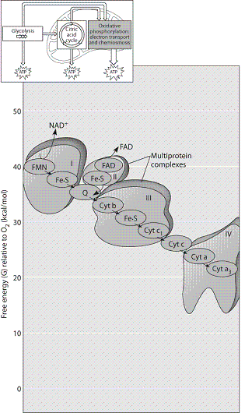

Figure 9.3

____ 19) Which of the protein complexes labeled with Roman numerals in Figure 9.3 will transfer electrons to O₂?
A) | complex I
B) | complex II
C) | complex III
D) | complex IV
E) | All of the complexes can transfer electrons to O₂.

ap bio practice review exam ch.9
Answer Section

MULTIPLE CHOICE

1) ANS: B PTS: 1 MSC: Knowledge/Comprehension

2) ANS: C PTS: 1 MSC: Knowledge/Comprehension

3) ANS: E PTS: 1 MSC: Knowledge/Comprehension

4) ANS: B PTS: 1 MSC: Knowledge/Comprehension

5) ANS: B PTS: 1 MSC: Knowledge/Comprehension

6) ANS: C PTS: 1 MSC: Knowledge/Comprehension

7) ANS: C PTS: 1 MSC: Synthesis/Evaluation

8) ANS: B PTS: 1 MSC: Knowledge/Comprehension

9) ANS: B PTS: 1 MSC: Knowledge/Comprehension

10) ANS: E PTS: 1 MSC: Knowledge/Comprehension

11) ANS: A PTS: 1 MSC: Application/Analysis

12) ANS: E PTS: 1 MSC: Knowledge/Comprehension

13) ANS: A PTS: 1 MSC: Synthesis/Evaluation

14) ANS: C PTS: 1 MSC: Knowledge/Comprehension

15) ANS: E PTS: 1 MSC: Knowledge/Comprehension

16) ANS: D PTS: 1 MSC: Knowledge/Comprehension

17) ANS: C PTS: 1 MSC: Application/Analysis

18) ANS: C PTS: 1 MSC: Application/Analysis

19) ANS: D PTS: 1 MSC: Knowledge/Comprehension

