Unit Practice Test chs. 22-25

Multiple Choice
Identify the choice that best completes the statement or answers the question.

____ 1) Which of the following statements best describes theories?
A) | They are nearly the same things as hypotheses.
B) | They are supported by, and make sense of, many observations.
C) | They cannot be tested because the described events occurred only once.
D) | They are predictions of future events.

____ 2) What was the prevailing belief prior to the time of Lyell and Darwin?
A) | Earth is a few thousand years old, and populations are unchanging.
B) | Earth is a few thousand years old, and populations gradually change.
C) | Earth is millions of years old, and populations rapidly change.
D) | Earth is millions of years old, and populations are unchanging.
E) | Earth is millions of years old, and populations gradually change.

____ 3) Given a population that contains genetic variation, what is the correct sequence of the following events, under the influence of natural selection?
1. Well–adapted individuals leave more offspring than do poorly adapted individuals.
2. A change occurs in the environment.
3. Genetic frequencies within the population change.
4. Poorly adapted individuals have decreased survivorship.
A) | 2 → 4 → 1 → 3
B) | 4 → 2 → 1 → 3
C) | 4 → 1 → 2 → 3
D) | 4 → 2 → 3 → 1
E) | 2 → 4 → 3 → 1

____ 4) Which of the following must exist in a population before natural selection can act upon that population?
A) | genetic variation among individuals
B) | variation among individuals caused by environmental factors
C) | sexual reproduction
D) | Three of the responses are correct.
E) | Two of the responses are correct.

____ 5) Both ancestral birds and ancestral mammals shared a common ancestor that was terrestrial. Today, penguins (which are birds) and seals (which are mammals) have forelimbs adapted for swimming. What term best describes the relationship of the bones in the forelimbs of penguins and seals, and what term best describes the flippers of penguins and seals?
A) | homologous; homologous
B) | analogous; homologous
C) | homologous; analogous
D) | analogous; analogous

The following questions refer to Figure 22.1, which shows an outcrop of sedimentary rock whose strata are labeled A–D.

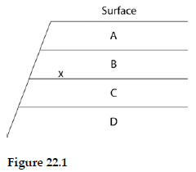

____ 6) If x indicates the location of fossils of two closely related species, then fossils of their most-recent common ancestor are most likely to occur in which stratum?
A) | A
B) | B
C) | C
D) | D

____ 7) If, on average, 46% of the loci in a species' gene pool are heterozygous, then the average homozygosity of the species should be
A) | 23%.
B) | 46%.
C) | 54%.
D) | There is not enough information to say.

____ 8) In the formula for determining a population's genotype frequencies, the 2 in the term 2pq is necessary because
A) | the population is diploid.
B) | heterozygotes can come about in two ways.
C) | the population is doubling in number.
D) | heterozygotes have two alleles.

The following questions refer to the evolutionary tree in Figure 22.2.

The horizontal axis of the cladogram depicted below is a timeline that extends from 100,000 years ago to the present; the vertical axis represents nothing in particular. The labeled branch points on the tree (V–Z) represent various common ancestors. Let’s say that only since 50,000 years ago has there been enough variation between the lineages depicted here to separate them into distinct species, and only the tips of the lineages on this tree represent distinct species.

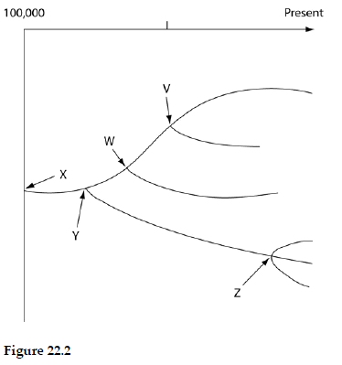

____ 9) According to this tree, what percent of the species seem to be extant (in other words, not extinct)?
A) | 25%
B) | 33%
C) | 50%
D) | 66%
E) | 75%

____ 10) Which of the five common ancestors, labeled V–Z, has given rise to the greatest number of species, both extant and extinct?
A) | V
B) | W
C) | Z
D) | Both W and Z can be considered to have given rise to the greatest number of extant and extinct species.
E) | Both X and Y can be considered to have given rise to the greatest number of extant and extinct species.

____ 11) In a Hardy–Weinberg population with two alleles, A and a, that are in equilibrium, the frequency of the allele a is 0.3. What is the percentage of the population that is homozygous for this allele?
A) | 0.09
B) | 0.49
C) | 0.9
D) | 9.0
E) | 49.0

____ 12) Sexual dimorphism is most often a result of
A) | pansexual selection.
B) | stabilizing selection.
C) | intrasexual selection.
D) | intersexual selection.
E) | artificial selection.

____ 13) Blue light is that portion of the visible spectrum that penetrates the deepest into bodies of water. Ultraviolet (UV) light, though, can penetrate even deeper. A gene within a population of marine fish that inhabits depths from 500 m to 1,000 m has an allele for a photopigment that is sensitive to UV light, and another allele for a photopigment that is sensitive to blue light. Which of the following graphs best depicts the predicted distribution of these alleles within a population if the fish that carry these alleles prefer to locate themselves where they can see best?
A) | 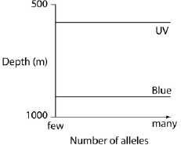 | C) | 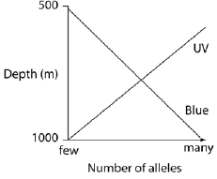
B) | 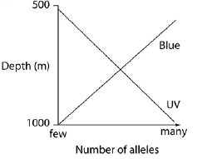 | D) | 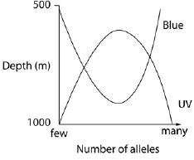

In a very large population, a quantitative trait has the following distribution pattern:

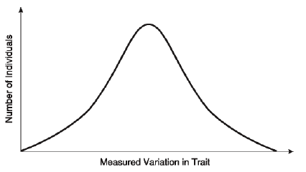

____ 14) What is true of the trait whose frequency distribution in a large population appears in the previous figure? It has probably undergone
A) | directional selection.
B) | stabilizing selection.
C) | disruptive selection.
D) | normal selection.

Use this information to answer the following questions.

A large population of laboratory animals has been allowed to breed randomly for a number of generations. After several generations, 25% of the animals display a recessive trait (aa), the same percentage as at the beginning of the breeding program. The rest of the animals show the dominant phenotype, with heterozygotes indistinguishable from the homozygous dominants.

____ 15) What is the most reasonable conclusion that can be drawn from the fact that the frequency of the recessive trait (aa) has not changed over time?
A) | The population is undergoing genetic drift.
B) | The two phenotypes are about equally adaptive under laboratory conditions.
C) | The genotype AA is lethal.
D) | There has been a high rate of mutation of allele A to allele a.
E) | There has been sexual selection favoring allele a.

____ 16) What is the estimated frequency of allele A in the gene pool?
A) | 0.25
B) | 0.50
C) | 0.75

____ 17) What is true of macroevolution?
A) | It is the same as microevolution, but includes the origin of new species.
B) | It is evolution above the species level.
C) | It is defined as the evolution of microscopic organisms into organisms that can be seen with the naked eye.
D) | It is defined as a change in allele or gene frequency over the course of many generations.
E) | It is the conceptual link between irritability and adaptation.

____ 18) Which of the following statements about species, as defined by the biological species concept, is (are) correct?
I. Biological species are defined by reproductive isolation.
II. Biological species are the model used for grouping extinct forms of life.
III. The biological species is the largest unit of population in which successful interbreeding is possible.
A) | I and II
B) | I and III
C) | II and III
D) | I, II, and III

____ 19) Dogs (Canis lupus familiaris) and gray wolves (Canis lupus) can interbreed to produce viable, fertile offspring. These species shared a common ancestor recently (in geologic time) and have a high degree of genetic similarity, although their anatomies vary widely. Judging from this evidence, which two species concepts are most likely to place dogs and wolves together into a single species?
A) | ecological and morphological
B) | ecological and phylogenetic
C) | morphological and phylogenetic
D) | biological and morphological
E) | biological and phylogenetic

____ 20) If the half–life of carbon–14 is about 5,730 years, then a fossil that has one–sixteenth the normal proportion of carbon–14 to carbon–12 should be about how many years old?
A) | 1,400
B) | 2,800
C) | 11,200
D) | 16,800
E) | 22,900

____ 21) Approximately how far back in time does the fossil record extend?
A) | 3.5 million years
B) | 5.0 million years
C) | 3.5 billion years
D) | 5.0 billion years

The next few questions refer to the following evolutionary tree, whose horizontal axis represents time (present time is on the far right) and whose vertical axis represents morphological change.

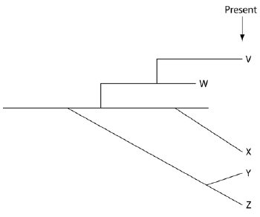

____ 22) Which species is most closely related to species W?
A) | V is most closely related to species W.
B) | X is most closely related to species W.
C) | Y and Z are equally closely related to W.
D) | It is not possible to say from this tree.

____ 23) Which of these five species is the extant (i.e., not extinct) species that is most closely related to species X, and why is this so?
A) | V; shared a common ancestor with X most recently
B) | W; shared a common ancestor with X most recently
C) | Y; arose in the same fashion (i.e., at the same tempo) as X
D) | Z; shared a common ancestor with X most recently, and arose in the same fashion as X
E) | This tree does not provide enough information to answer this question.

____ 24) According to the punctuated equilibria model,
A) | natural selection is unimportant as a mechanism of evolution.
B) | given enough time, most existing species will branch gradually into new species.
C) | most new species accumulate their unique features relatively rapidly as they come into existence, then change little for the rest of their duration as a species.
D) | most evolution occurs in sympatric populations.
E) | speciation is usually due to a single mutation.

____ 25) Which of the following is the correct sequence of events in the origin of life?
I. formation of protobionts
II. synthesis of organic monomers
III. synthesis of organic polymers
IV. formation of DNA–based genetic systems
A) | I, II, III, IV
B) | I, III, II, IV
C) | II, III, I, IV
D) | II, III, IV, I

The following questions refer to the paragraph below.

A sediment core is removed from the floor of an inland sea. The sea has been in existence, off and on, throughout the entire time that terrestrial life has existed. Researchers wish to locate and study the terrestrial organisms fossilized in this core. The core is illustrated as a vertical column, with the top of the column representing the most recent strata and the bottom representing the time when land was first colonized by life.

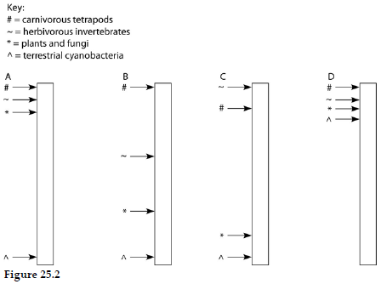

____ 26) If arrows indicate locations in the column where fossils of a particular type (see key above) first appear, then which core in Figure 25.2 has the most accurate arrangement of fossils?
A) | core A
B) | core B
C) | core C
D) | core D

Unit Practice Test chs. 22-25
Answer Section

MULTIPLE CHOICE

1) ANS: B PTS: 1 MSC: Knowledge/Comprehension

2) ANS: A PTS: 1 MSC: Knowledge/Comprehension

3) ANS: A PTS: 1 MSC: Synthesis/Evaluation

4) ANS: A PTS: 1 MSC: Knowledge/Comprehension

5) ANS: C PTS: 1 MSC: Application/Analysis

6) ANS: A PTS: 1 MSC: Application/Analysis

7) ANS: C PTS: 1 MSC: Knowledge/Comprehension

8) ANS: B PTS: 1 MSC: Knowledge/Comprehension

9) ANS: D PTS: 1 MSC: Application/Analysis

10) ANS: E PTS: 1 MSC: Application/Analysis

11) ANS: D PTS: 1 MSC: Application/Analysis

12) ANS: D PTS: 1 MSC: Knowledge/Comprehension

13) ANS: B PTS: 1 MSC: Application/Analysis

14) ANS: B PTS: 1 MSC: Knowledge/Comprehension

15) ANS: B PTS: 1 MSC: Knowledge/Comprehension

16) ANS: B PTS: 1 MSC: Application/Analysis

17) ANS: B PTS: 1 MSC: Knowledge/Comprehension

18) ANS: B PTS: 1 MSC: Knowledge/Comprehension

19) ANS: E PTS: 1 MSC: Application/Analysis

20) ANS: E PTS: 1 MSC: Application/Analysis

21) ANS: C PTS: 1 MSC: Knowledge/Comprehension

22) ANS: A PTS: 1 MSC: Application/Analysis

23) ANS: A PTS: 1 MSC: Application/Analysis

24) ANS: C PTS: 1 MSC: Knowledge/Comprehension

25) ANS: C PTS: 1 MSC: Knowledge/Comprehension

26) ANS: A PTS: 1 MSC: Application/Analysis

