Unit Practice Test: Cell division & genetic inheritance

Multiple Choice
Identify the choice that best completes the statement or answers the question.

____ 1) Starting with a fertilized egg (zygote), a series of five cell divisions would produce an early embryo with how many cells?
A) | 4
B) | 8
C) | 16
D) | 32
E) | 64

____ 2) If there are 20 chromatids in a cell, how many centromeres are there?
A) | 10
B) | 20
C) | 30
D) | 40
E) | 80

____ 3) If cells in the process of dividing are subjected to colchicine, a drug that interferes with the formation of the spindle apparatus, at which stage will mitosis be arrested?
A) | anaphase
B) | prophase
C) | telophase
D) | metaphase
E) | interphase

____ 4) A group of cells is assayed for DNA content immediately following mitosis and is found to have an average of 8 picograms of DNA per nucleus. How many picograms would be found at the end of S and the end of G₂?
A) | 8; 8
B) | 8; 16
C) | 16; 8
D) | 16; 16
E) | 12; 16

____ 5) All cell cycle checkpoints are similar in which way?
A) | They respond to the same cyclins.
B) | They utilize the same Cdks.
C) | They give the go–ahead signal to progress to the next checkpoint.
D) | They each have only one cyclin/Cdk complex.
E) | They activate or inactivate other proteins.

Use the following information to answer the questions below.

The lettered circle in Figure 12.1 shows a diploid nucleus with four chromosomes. There are two pairs of homologous chromosomes, one long and the other short. One haploid set is symbolized as black and the other haploid set is gray. The chromosomes in the unlettered circle have not yet replicated. Choose the correct chromosomal conditions for the following stages.

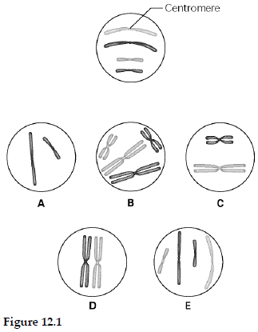

____ 6) What is the correct chromosomal condition at the prometaphase of mitosis?
A) | A
B) | B
C) | C
D) | D
E) | E

The following questions are based on Figure 12.3.

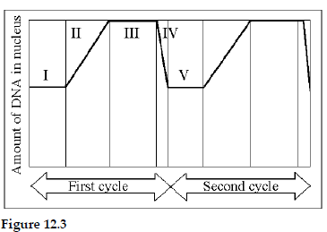

____ 7) In the figure above, mitosis is represented by which numbered part(s) of the cycle?
A) | I
B) | II
C) | III
D) | IV
E) | V

____ 8) At which of the numbered regions would you expect to find cells at metaphase?
A) | I and IV
B) | II only
C) | III only
D) | IV only
E) | V only

Use the following information to answer the questions below.

A student is looking through his light microscope (~450 X) at a squashed and stained onion root tip. Some, but not all, of the cells have clearly visible chromosome strands.

____ 9) When a cell is in anaphase of mitosis, which of the following will he see?
A) | a clear area in the center of the cell
B) | chromosomes clustered at the poles
C) | individual chromatids separating
D) | chromosomes clustered tightly at the center
E) | formation of vesicles at the midline

____ 10) The human X and Y chromosomes
A) | are both present in every somatic cell of males and females alike.
B) | are of approximately equal size and number of genes.
C) | are almost entirely homologous, despite their different names.
D) | include genes that determine an individual's sex.
E) | include only genes that govern sex determination.

____ 11) Which of the following is true of a species that has a chromosome number of 2 n = 16?
A) | The species is diploid with 32 chromosomes per cell.
B) | The species has 16 sets of chromosomes per cell.
C) | Each cell has eight homologous pairs.
D) | During the S phase of the cell cycle there will be 32 separate chromosomes.
E) | A gamete from this species has four chromosomes.

____ 12) A triploid cell contains three sets of chromosomes. If a cell of a usually diploid species with 42 chromosomes per cell is triploid, this cell would be expected to have which of the following?
A) | 63 chromosomes in 31 1/2 pairs
B) | 63 chromosomes in 21 sets of 3
C) | 63 chromosomes, each with three chromatids
D) | 21 chromosome pairs and 21 unique chromosomes

____ 13) If a cell has completed the first meiotic division and is just beginning meiosis II, which of the following is an appropriate description of its contents?
A) | It has half the amount of DNA as the cell that began meiosis.
B) | It has the same number of chromosomes but each of them has different alleles than another cell from the same meiosis.
C) | It has half the chromosomes but twice the DNA of the originating cell.
D) | It has one–fourth the DNA and one–half the chromosomes as the originating cell.
E) | It is identical in content to another cell from the same meiosis.

Refer to the drawings in Figure 13.2 of a single pair of homologous chromosomes as they might appear during various stages of either mitosis or meiosis, and answer the following questions.

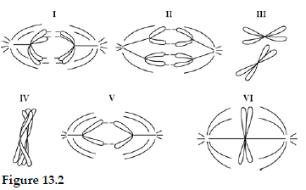

____ 14) Which diagram represents anaphase I of meiosis?
A) | I
B) | II
C) | IV
D) | V
E) | VI

You have isolated DNA from three different cell types of an organism, determined the relative DNA content for each type, and plotted the results on the graph shown in Figure 13.3. Refer to the graph to answer the following questions.

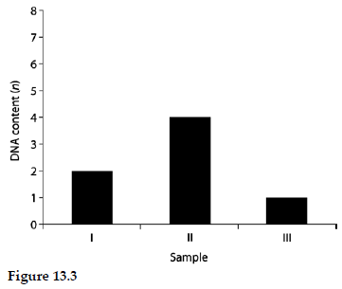

____ 15) Which sample of DNA might be from a nerve cell arrested in G₀ of the cell cycle?
A) | I
B) | II
C) | III
D) | either I or II
E) | either I or III

____ 16) A human cell containing 22 autosomes and a Y chromosome is
A) | a sperm.
B) | an egg.
C) | a zygote.
D) | a somatic cell of a male.
E) | a somatic cell of a female.

____ 17) A sexually reproducing animal has two unlinked genes, one for head shape ( H) and one for tail length (T). Its genotype is HhTt. Which of the following genotypes is possible in a gamete from this organism?
A) | tt
B) | Hh
C) | HhTt
D) | T
E) | HT

____ 18) When crossing an organism that is homozygous recessive for a single trait with a heterozygote, what is the chance of producing an offspring with the homozygous recessive phenotype?
A) | 0%
B) | 25%
C) | 50%
D) | 75%
E) | 100%

____ 19) Black fur in mice (B) is dominant to brown fur ( b). Short tails (T) are dominant to long tails ( t). What fraction of the progeny of crosses BbTt × BBtt will be expected to have black fur and long tails?
A) | 1/16
B) | 3/16
C) | 3/8
D) | 1/2
E) | 9/16

Use Figure 14.1 and the following description to answer the questions below.

In a particular plant, leaf color is controlled by gene locus D. Plants with at least one allele D have dark green leaves, and plants with the homozygous recessive dd genotype have light green leaves. A true-breeding dark-leaved plant is crossed with a light-leaved one, and the F₁ offspring is allowed to self-pollinate. The predicted outcome of the F₂ is diagrammed in the Punnett square shown in Figure 14.1, where 1, 2, 3, and 4 represent the genotypes corresponding to each box within the square.

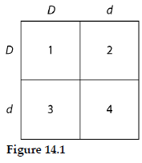

____ 20) Which of the boxes marked 1–4 correspond to plants with dark leaves?
A) | 1 only
B) | 1 and 2
C) | 2 and 3
D) | 4 only
E) | 1, 2, and 3

The following questions refer to the pedigree chart in Figure 14.2 for a family, some of whose members exhibit the dominant trait, W. Affected individuals are indicated by a dark square or circle.

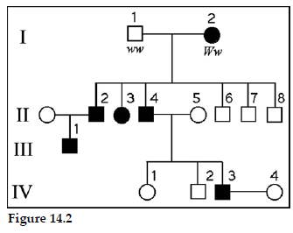

____ 21) What is the genotype of individual II–5?
A) | WW
B) | Ww
C) | ww
D) | WW or ww
E) | ww or Ww

____ 22) What is the likelihood that the progeny of IV–3 and IV–4 will have the trait?
A) | 0%
B) | 25%
C) | 50%
D) | 75%
E) | 100%

Use the following pedigree (Figure 14.3) for a family in which dark-shaded symbols represent individuals with one of the two major types of colon cancer. Numbers under the symbols are the individual’s age at the time of diagnosis.

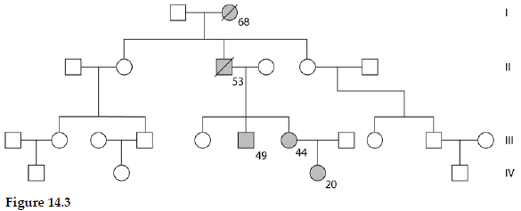

____ 23) What is the genotype of the deceased individual in generation II?
A) | homozygous for a gene for colon cancer
B) | homozygous for both cancer alleles from his mother
C) | heterozygous for a gene for colon cancer
D) | affected by the same colon cancer environmental factor as his mother
E) | carrier of all of the several known genes for colon cancer

Use the following information to answer the questions below.

Tallness (T) in snapdragons is dominant to dwarfness (t), while red (R) flower color is dominant to white (r). The heterozygous condition results in pink (Rr) flower color.

____ 24) A dwarf, red snapdragon is crossed with a plant homozygous for tallness and white flowers. What are the genotype and phenotype of the F₁ individuals?
A) | ttRr—dwarf and pink
B) | ttrr—dwarf and white
C) | TtRr—tall and red
D) | TtRr—tall and pink
E) | TTRR—tall and red

____ 25) In cats, black fur color is caused by an X–linked allele; the other allele at this locus causes orange color. The heterozygote is tortoiseshell. What kinds of offspring would you expect from the cross of a black female and an orange male?
A) | tortoiseshell females; tortoiseshell males
B) | black females; orange males
C) | orange females; orange males
D) | tortoiseshell females; black males
E) | orange females; black males

____ 26) Red-green color blindness is a sex-linked recessive trait in humans. Two people with normal color vision have a color-blind son. What are the genotypes of the parents?
A) | X^{c}X^{c} and X^{c}Y
B) | X^{c}X^{c} and X^{C}Y
C) | X^{C}X^{C} and X^{c}Y
D) | X^{C}X^{C} and X^{C}Y
E) | X^{C}X^{c} and X^{C}Y

____ 27) What is the reason that linked genes are inherited together?
A) | They are located close together on the same chromosome.
B) | The number of genes in a cell is greater than the number of chromosomes.
C) | Chromosomes are unbreakable.
D) | Alleles are paired together during meiosis.
E) | Genes align that way during metaphase I of meiosis.

____ 28) In humans, male–pattern baldness is controlled by an autosomal gene that occurs in two allelic forms. Allele Hn determines nonbaldness, and allele Hb determines pattern baldness. In males, because of the presence of testosterone, allele Hb is dominant over Hn. If a man and woman both with genotype HnHb have a son, what is the chance that he will eventually be bald?
A) | 0%
B) | 25%
C) | 33%
D) | 50%
E) | 75%

____ 29) A certain kind of snail can have a right–handed direction of shell coiling ( D) or left–handed coiling (d). If direction of coiling is due to a protein deposited by the mother in the egg cytoplasm, then a Dd egg–producing snail and a dd sperm–producing snail will have offspring of which genotype(s) and phenotype(s)?
A) | 1/2 Dd:1/2 dd; all right coiling
B) | all Dd; all right coiling
C) | 1/2 Dd:1/2 dd; half right and half left coiling
D) | all Dd; all left coiling
E) | all Dd; half right and half left coiling

Refer to the following information to answer the questions below.

A man who is an achondroplastic dwarf with normal vision marries a color–blind woman of normal height. The man’s father was 6 feet tall, and both the woman’s parents were of average height. Achondroplastic dwarfism is autosomal dominant, and red-green color blindness is X–linked recessive.

____ 30) How many of their daughters might be expected to be color–blind dwarfs?
A) | all
B) | none
C) | half
D) | one out of four
E) | three out of four

____ 31) Cytosine makes up 42% of the nucleotides in a sample of DNA from an organism. Approximately what percentage of the nucleotides in this sample will be thymine?
A) | 8%
B) | 16%
C) | 31%
D) | 42%
E) | It cannot be determined from the information provided.

____ 32) In an analysis of the nucleotide composition of DNA, which of the following will be found?
A) | A = C
B) | A = G and C = T
C) | A + C = G + T
D) | G + C = T + A

____ 33) What is meant by the description "antiparallel" regarding the strands that make up DNA?
A) | The twisting nature of DNA creates nonparallel strands.
B) | The 5' to 3' direction of one strand runs counter to the 5' to 3' direction of the other strand.
C) | Base pairings create unequal spacing between the two DNA strands.
D) | One strand is positively charged and the other is negatively charged.
E) | One strand contains only purines and the other contains only pyrimidines.

____ 34) Which enzyme catalyzes the elongation of a DNA strand in the 5' 3' direction?
A) | primase
B) | DNA ligase
C) | DNA polymerase III
D) | topoisomerase
E) | helicase

____ 35) At a specific area of a chromosome, the sequence of nucleotides below is present where the chain opens to form a replication fork:
3' C C T A G G C T G C A A T C C 5'
An RNA primer is formed starting at the underlined T ( T) of the template. Which of the following represents the primer sequence?
A) | 5' G C C T A G G 3'
B) | 3' G C C T A G G 5'
C) | 5' A C G T T A G G 3'
D) | 5' A C G U U A G G 3'
E) | 5' G C C U A G G 3'

____ 36) Which of the following statements describes the eukaryotic chromosome?
A) | It is composed of DNA alone.
B) | The nucleosome is its most basic functional subunit.
C) | The number of genes on each chromosome is different in different cell types of an organism.
D) | It consists of a single linear molecule of double–stranded DNA plus proteins.
E) | Active transcription occurs on heterochromatin but not euchromatin.

Unit Practice Test: Cell division & genetic inheritance
Answer Section

MULTIPLE CHOICE

1) ANS: D PTS: 1 MSC: Application/Analysis

2) ANS: A PTS: 1 MSC: Application/Analysis

3) ANS: D PTS: 1 MSC: Application/Analysis

4) ANS: D PTS: 1 MSC: Application/Analysis

5) ANS: E PTS: 1 MSC: Knowledge/Comprehension

6) ANS: B PTS: 1 MSC: Knowledge/Comprehension

7) ANS: D PTS: 1 MSC: Application/Analysis

8) ANS: C PTS: 1 MSC: Application/Analysis

9) ANS: A PTS: 1 MSC: Application/Analysis

10) ANS: D PTS: 1 MSC: Knowledge/Comprehension

11) ANS: C PTS: 1 MSC: Application/Analysis

12) ANS: B PTS: 1 MSC: Synthesis/Evaluation

13) ANS: A PTS: 1 MSC: Application/Analysis

14) ANS: A PTS: 1 MSC: Application/Analysis

15) ANS: A PTS: 1 MSC: Application/Analysis

16) ANS: A PTS: 1 MSC: Knowledge/Comprehension

17) ANS: E PTS: 1 MSC: Application/Analysis

18) ANS: C PTS: 1 MSC: Application/Analysis

19) ANS: D PTS: 1 MSC: Application/Analysis

20) ANS: E PTS: 1 MSC: Application/Analysis

21) ANS: C PTS: 1 MSC: Application/Analysis

22) ANS: C PTS: 1 MSC: Application/Analysis

23) ANS: C PTS: 1 MSC: Application/Analysis

24) ANS: D PTS: 1 MSC: Application/Analysis

25) ANS: D PTS: 1 MSC: Application/Analysis

26) ANS: E PTS: 1 MSC: Application/Analysis

27) ANS: A PTS: 1 MSC: Knowledge/Comprehension

28) ANS: E PTS: 1 MSC: Application/Analysis

29) ANS: A PTS: 1 MSC: Application/Analysis

30) ANS: B PTS: 1 MSC: Application/Analysis

31) ANS: A PTS: 1 MSC: Application/Analysis

32) ANS: C PTS: 1 MSC: Application/Analysis

33) ANS: B PTS: 1 MSC: Knowledge/Comprehension

34) ANS: C PTS: 1 MSC: Knowledge/Comprehension

35) ANS: D PTS: 1 MSC: Synthesis/Evaluation

36) ANS: D PTS: 1 MSC: Knowledge/Comprehension

